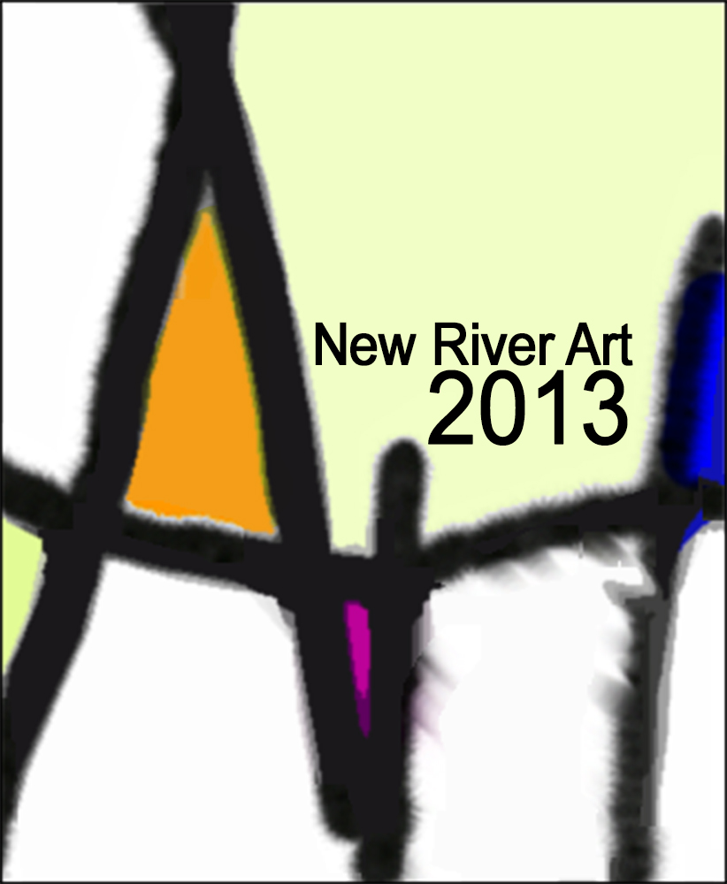
New River Art Biennial 2013

Winners (presented Oct. 18, Perspective Gallery reception)

Nadine Allen Memorial Award: Nick Vitelli, Christiansburg, “Cuba”
Award of Excellence: Sean Hatter, Check, “Portrait of Philip”
First Award of Distinction: Dave Wertz, Roanoke, “Well, Kiss my Sweet Ass”
Second Award of Distinction: Lily Erb, Afton, “Appalachia”
Award of Merit: W. Dale Norton, Blacksburg, “Wanderings”
Most Innovative: Gina Louthian-Stanley, Roanoke, “Caged Window”
Honorable Mention: Julie Hawk, Christiansburg, “Presence of the Circle II”
Honorable Mention: Jennifer Carpenter, Christiansburg, “A Flare to Remember”

Great appreciation to the following for making the $2100 prize fund possible:

Nadine Allen Memorial Fund (daughters Mary Woerner and Margaret Feay)
Steve Miller, Mish Mish Art Supply, Blacksburg
Ruth Waalkes and the personnel of Center for the Arts at Virginia Tech, Blacksburg
John Eustis, New River Land Trust, Blacksburg
Robert Miller, Miller off Main St. Galleries, Blacksburg
Leslye Bloom, Blacksburg
Vera Dickerson, The Studio School, Roanoke
Diana Francis and James Creekmore, The Artful Lawyer, Blacksburg

2013 supporting organizations:

Blacksburg Regional Art Association, coordinator/administrator/donor
Robi Sallee, President
Leslye Bloom, Committee Chair
Gerri Young, committee member
Diana Francis, committee member

Jacksonville Center for the Arts, Floyd, donor, John McEnhill, director
Fine Arts Center for the New River Valley, Pulaski, Judy Ison, director

Perspective Gallery, VT, Robin Boucher, director
New River Land Trust, John Eustis, director

2015 Biennial will be headed by Judy Ison, Fine Arts Center for the New River Valley

